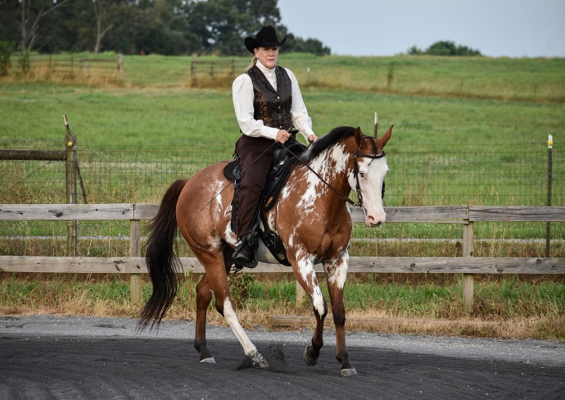
Western Dressage of GA invites you to our first “Calico Clinic”
Ride-A-Test

In honor of our very own Truly Unsurpassed, aka “Calico”, owned and shown by Nancy Conley. The 1st WDAA Gold medal horse & USEF WD Horse of the Year

Saturday, February 26, 2022
North Atlanta Equestrian Center – Cartersville, GA
Honorable Judge Donna Richardson, USEF “S”, WD “R”
Open to Riders AND auditors. Each rider is assigned a ride time where you will ride ONE test of choice for the judge. The judge will then review your test and select 1-2 areas of focus to work on with you and your horse for approximately 20 minutes. Then, you will re-ride your test for the judge. What a FANTASTIC way to learn the new tests and MAXIMIZE your scores!!!! All riders are welcome to stay for the day and watch and learn from others. Auditors can watch the whole day as well. Bring a chair, snacks and a notebook!
Rider Slots: 2022 WDAGA Members - $125 (per test)
Non-Members $150 (per test)
Auditor Slots: 2022 WDAGA Members $20
Non-Members $25
All attendees must bring THREE copies of the test(s) you are riding and sign a WDAGA Hold Harmless Agreement. Proper tack/equipment required and must be within rules. To register, fill out the attached form or, go to our website at www.wdageorgia.com
WDAGA “Calico Clinic”
Ride-A-Test Registration Form

____RIDER ____AUDITOR

WDAGA Member ? __YES __NO Membership #________

Name: ____________________________________

Email: ____________________________________

Phone: _________ Horse: ____________________

Circle all time slots you are available (please note-we will do our best to accommodate time requests but CANNOT guarantee)
10:00 10:30 11:00 11:30 12:00 12:30 1:00 1:30
2:00 2:30 3:00 3:30 4:00 4:30

You are responsible for your ride times just like at a show. You will need to warm up and be ready to enter the arena on time. You are also responsible for bringing/hiring your test caller. ONLY 2022 WDAA Tests will be used so please print the new ones from the WDAA website. Please note that no stalls are available, all horses will be tied to trailers on site.
We are SUPER excited to be offering such a great learning opportunity this year to our members! Spread the word and come join us.

