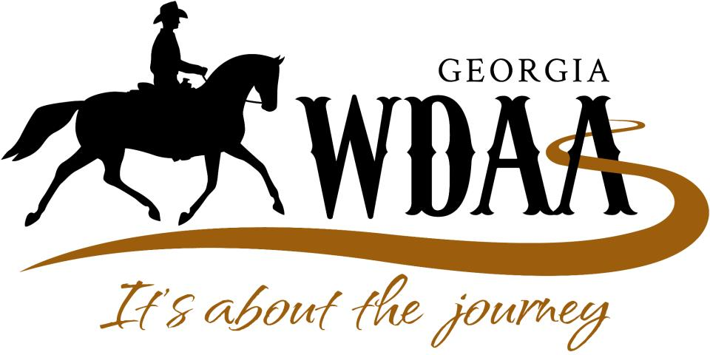 WDAGA HOLD HARMLESS AGREEMENT
The undersigned competitor and all signors below hereby (1) agrees to release the management of this show, their officers, directors, employees, members, or agents, and the owners or managers of the grounds where this event is held, from any loss, damage, liability, or injury arising out of or resulting from this show or competitors participation therein; (2) agrees to indemnify, hold harmless and defend the Georgia Western Dressage Association, the organizer, facility owner, and the management of this show from and against any and all claims for loss, damage, liability, or injury, however caused, resulting directly or indirectly from competitors entry or participation in this show or from acts or omissions of competitor or competitor’s agents; and (3) acknowledges that activities with and around horses and horse shows involve inherent risks that are understood by the persons signing and are expressly assumed. In the event of injury to competitor or to competitor’s animals permission is hereby granted to management for emergency medical treatment. Every entry at a Georgia Western Dressage Association (WDAGA) recognized competition shall constitute an agreement and affirmation that all participants (which include, without limitation, the owner, lessee, trainer, manager, agent, coach, driver, handler, and the horse), for themselves, their principals, representatives, employees, and agents: (1) shall be subject to the constitution and rules of the WDAGA and the local rules of the competition; (2) represent that every horse, rider, driver, and handler is eligible as entered; (3) agree to be bound by the constitution and rules of the United States Equestrian Federation (USEF) and of the competition, and will accept as final the decision of the hearing committee on any question arising under said rules, and agree to hold the competition, the WDAGA, their officials, directors and employees harmless for any action taken; (4) agree that as a condition of and in consideration of acceptance of entry, they authorize the WDAGA and the competition management to market, transfer, assign, or otherwise make use of any photographs, likenesses, films, broadcasts, cablecasts, audiotapes, or videotapes taken of the horse(s) and participant(s) while on the grounds, incident to, or in transit between the stabling facility and the event site, in any way they see fit for the promotion, coverage, or benefit of the event, sport, or the WDAGA, without compensation to any of them, so long as the use neither jeopardizes amateur status nor endorses a specific product or service, and hereby expressly and irrevocably waive and release any rights in connection with such use, including any claim to invasion of privacy, right of publicity, or to misappropriation; and (5) agree that they participate voluntarily in the competition fully aware that horse sports and the competition involve inherent dangerous risk of serious injury or death, and by participating they expressly assume any and all risks of injury or loss, and they agree to indemnify and hold harmless the WDAGA, the competition, and the officials, directors, employees, and agents from and against all claims including for any injury or loss suffered during or in connection with the competition, whether or not such claim, injury, or loss resulted, directly or indirectly, from the negligent acts or omissions of said officials, directors, employees, or agents of the WDAGA or competition. The construction and application of USEF Rules are governed by laws of the State of New York, and any action instituted against USEF must be filed in New York State, see Article 1502.5.
WARNING Under Georgia law, an equine activity sponsor or equine professional is not liable for an injury to or the death of a participant in equine activities resulting from the inherent risks of equine activities, pursuant to Chapter 12 of Title 4 of the Official Code of Georgia Annotated.

Signed: ______________________________________ Date: _______________
(Rider/Driver/Handler) (Mandatory)
Signed: ______________________________________ Date: _______________
(Horse Owner/Agent) (Mandatory)
Signed: ______________________________________ Date: _______________
(Trainer) (Mandatory)
Signed: ______________________________________ Date: _______________
(Parent/Guardian) (If rider is under age 18)
Signed: ______________________________________ Date: ______________
(Coach) (If applicable)

